HBS Rental System Setup Process
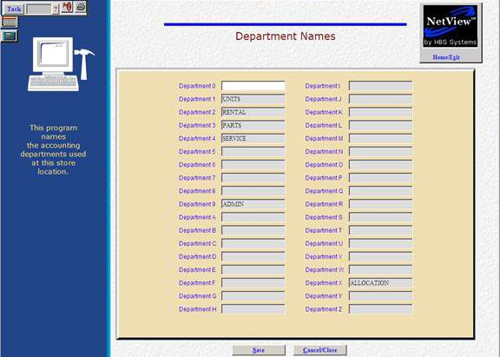
The next step is to identify the Rental department in Department Names (DNAM). To access this function, select the following from the menu:
System Maintenance / Company File / Department Names
Or type DNAM in the Shortcuts Bar
To create a department for Rental, enter “Rental” in the field next to the desired department number or letter. Any applicable accounts relating directly to the department will then end in that number or letter. In the example above, Rental is defined as Department 2, meaning all applicable accounts relating directly to that department would end in a 2.

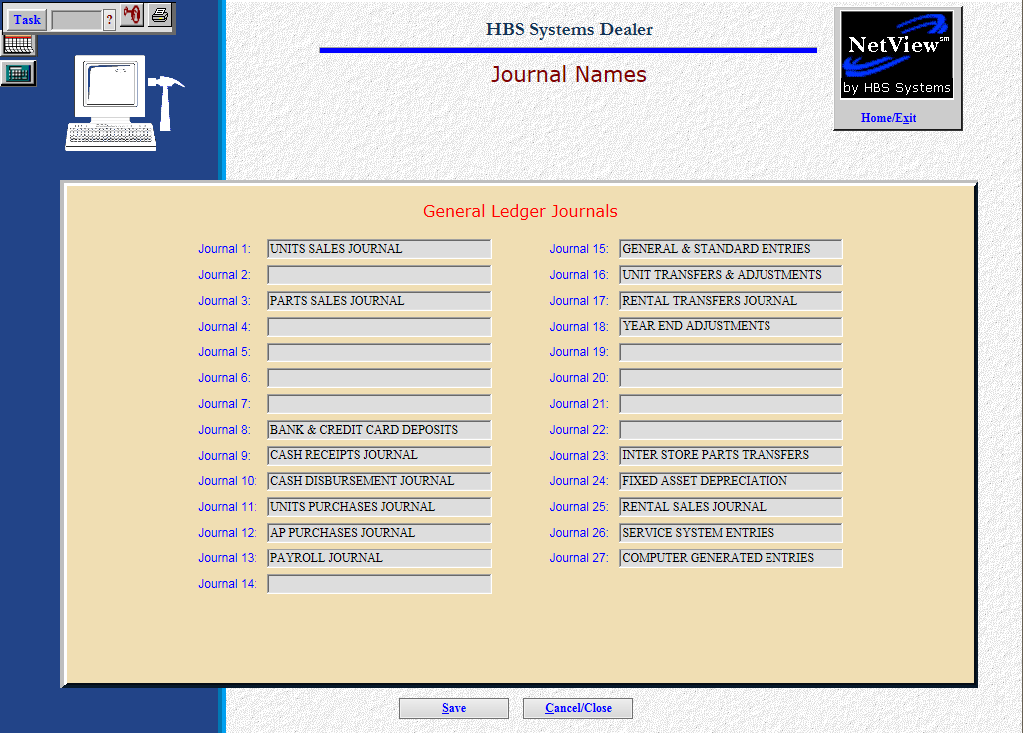
Next, use Journal Names (JNAM) to define the Rental Journal numbers to use in the system. To access this function, select the following from the menu:
System Maintenance / Company File / Journal Names
Or type JNAM in the Shortcuts Bar

You will need to define both the Rental Transfers & Adjustments Journal and the Rental Sales Journal. To do so, simply enter the Journal name in an available space and click the Save button.

Note that Journal 17 is the system’s default Journal for Rental Transfers & Adjustments, so we recommend using the default rather than setting up a separate Journal for the purpose.

Also note that Journal 16 defaults to Unit Transfers & Adjustments, so avoid using it for a Rental Journal.

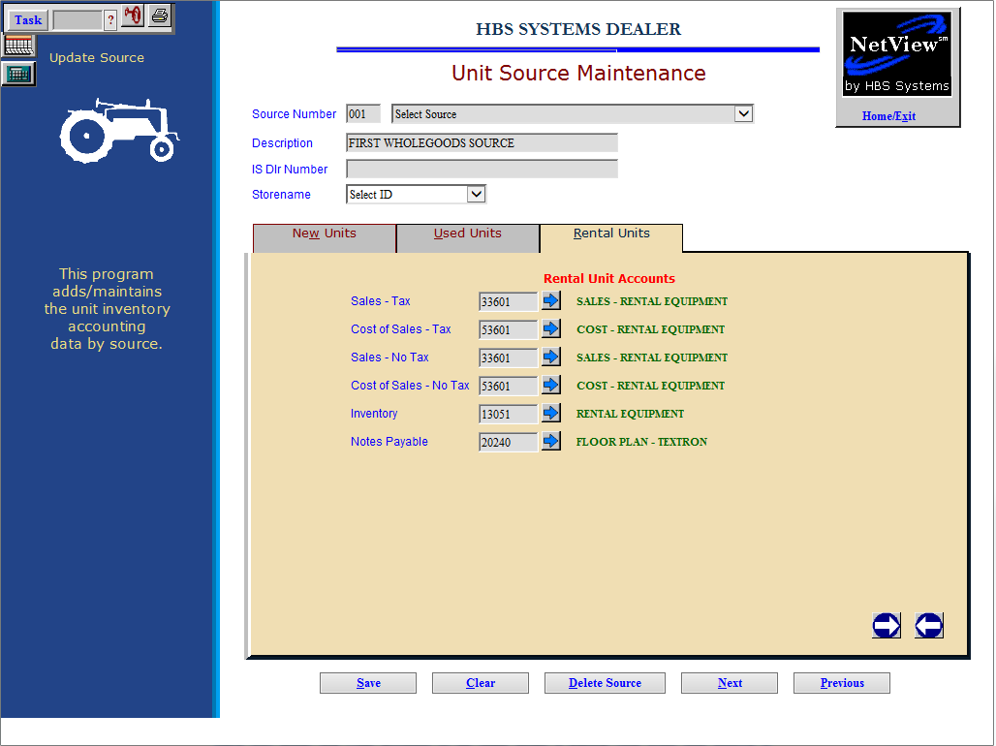
Next, use Unit Source Maintenance (USM) to add Rental Unit accounts to Unit sources that provide for your Rental department. To access this function, select the following from the menu:
Units / Data Entry / Unit Source Maintenance
Or type USM in the Shortcuts Bar
Select the Unit source you wish to add Rental Unit accounts to, then click the Rental Units tab.

Field Definitions

Sales Tax
This field functions exactly as it does for new or used equipment. Here you enter the Sale account to be used when a unit from this source is being sold while in the Rental system and the transaction is taxable. Type in the General Ledger account number or search for it using the arrow icon.

Cost of Sales - Tax
Here you enter the Cost account to be used when a unit from this source is being sold while in the Rental system and the transaction is taxable. Type in the General Ledger account number or search for it using the arrow icon.



Cost of Sale – No Tax
Here you enter the Sale account to be used when a unit from this source is being sold while in the Rental system and the transaction is nontaxable. Type in the General Ledger account number or search for it using the arrow icon.

Inventory
This field holds the General Ledger account number for the Inventory account where the value of the Rental units for this source is kept. Type in the General Ledger account number or search for it using the arrow icon.

Notes Payable
This field holds the General Ledger account number for the Notes Payable account where the liability of the Rental units for this source is kept. Type in the General Ledger account number or search for it using the arrow icon.
Click Save once you have filled in all the account fields. Repeat the procedure on all Unit sources associated with your Rental department.

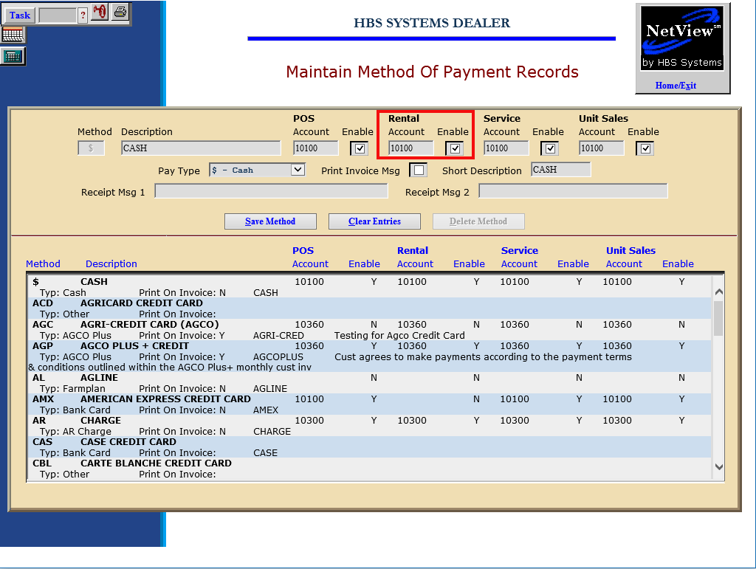
Then use Method of Payment (MOP) to define the possible ways your customers settle or pay for their rentals. Examples: Cash, Checks, Customer Deposits, Charge (A/R), Credit Cards, Financing (Contracts), etc. To access this function, select the following from the menu:
System Maintenance / Company File / Method of Payment
Or type MOP in the Shortcuts Bar

Field Definitions

Method
This is a 3-character code for the method of payment defined. It is used for record maintenance and does not appear in the invoicing programs.

Description
This field holds the description of the method of payment that will print on the invoice.

Rental Account
This field defines the General Ledger account that will receive the amount specified for this method of payment. You must click on the Enable field to its right to activate it. Choose the appropriate G/L Rental account for this method of payment.



Enable Rental Account
Click on this field to the right of the Rental Account field to use it in the identified invoicing screen.

Pay Type
This field identifies the type of payment defined. The values for this field are shown in the drop-down menu. Several choices for this field trigger the selection to work with interfaces to the HBS system: B-Bank Card, D-Debit, F-Farmplan, U-AGCO Plus.
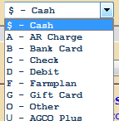

Print Invoice Msg
This choice is only checked if the payment is Farm Plan.
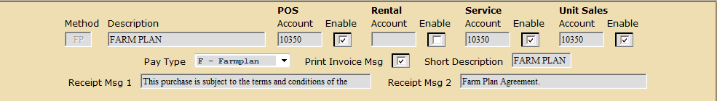

Short Description
This field holds a short version of the description that displays in selection boxes. You can enter up to 11 characters here.

Receipt Msg 1 & 2
These fields are only used if the payment is Farm Plan.

Press the “Save” button to save the record.

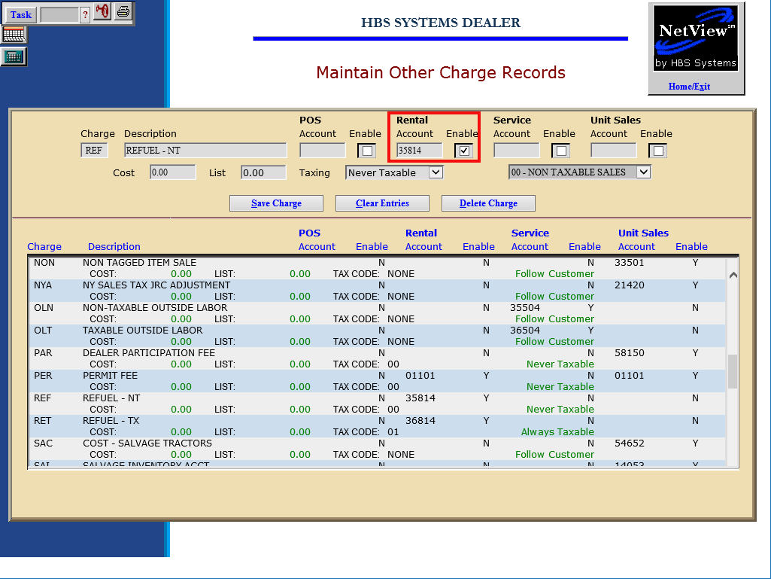
Finally, use Other Charge Maintenance (OCM) to define additional charges for Rental. These additional charges are line items that can be added to the invoice. Examples: Sales Tax, Delivery Fees, Fuel, Set-Up, UCC Fees, Extended Warranty, Trade Pay Off, etc. To access this function, select the following from the menu:
System Maintenance / Company File / Other Charges
Or type OCM in the Shortcuts Bar

Field Definitions

Charge
This is a 3-character code for the other charge defined. It is used for record maintenance and does not appear on the invoice.

Description
This field holds the description of the other charge that will print on the invoice.

Rental Account
This field holds the General Ledger account that will receive the amount for this method of payment. Click on the Enable field to its right to activate it. Choose the appropriate account for Rental for this method of payment.

Enable
Click on this field to the right of the Rental Account field to use it in the identified invoicing screen.

Cost
This field can hold the cost of the Other Charge. It should only be filled in if the cost is ALWAYS the same.

List
This field can hold the selling price of the Other Charge. If the price of this Other Charge is always the same, it could be entered here.
Taxing
This field can indicate the Other Charge’s taxable status. The options are: Always Taxable, Never Taxable, and Follow Customer.
Press the “Save Charge” button to save the record.

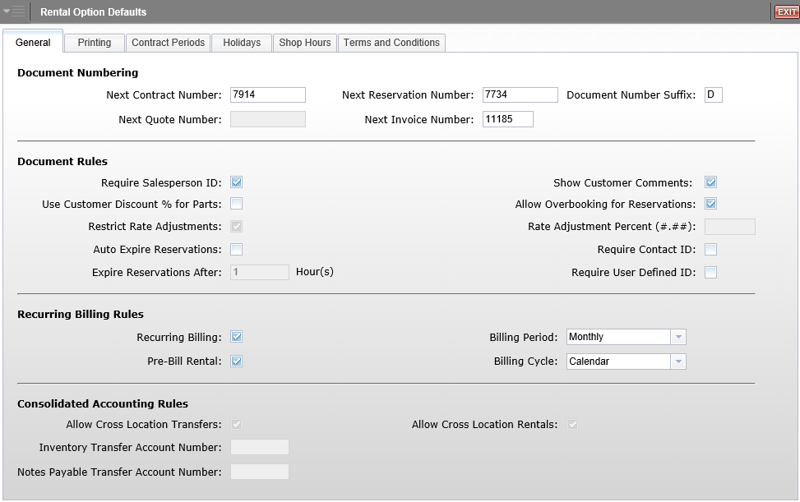
This screen provides the setup options and defaults for many of the Rental functions. Defaults are grouped together in tabs for easier navigation. To access this function, select the following from the menu:
Rental / Rental Options and Defaults
Or type ROD in the Shortcuts Bar

Field Definitions – General Tab

General - Document Numbering
This section provides fields to hold the next numbers for the following documents:

- Next Contract Number
- Next Quote Number
- Next Reservation Number
- Next Invoice Number
- Document Numbers Suffix (Typically used in multi-location setups)

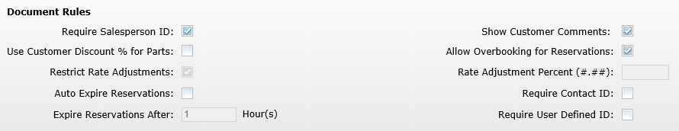

General - Document Rules
This section provides fields for general rules for some of the Rental functions on a reservation or contract.

Require Salesperson ID
This box determines if you want to require the Salesperson ID on a rental reservation or contract. Check the box if you do or leave it blank if you don’t.

Show Customer Comments
Check this field to display customer comments, should they exist, every time you open a reservation or contract for a customer. Leave blank otherwise.

Use Customer Discount % for Parts
This box determines if you want to use the Discount % in Enter Customer Information (ECI) for the Rental parts on a reservation or contract. Check the box if you do or leave it blank if you don’t.

Allow Overbooking for Reservations
This setting allows you to intentionally overbook rental reservations, meaning you can overlap rental reservations that vie for the same time period. Check the box to activate the option or leave it unchecked to prevent overbooking units for the same time period.

Restrict Rate Adjustments / Rate Adjustment Percent
These 2 fields offer the ability to control the adjustments of rental rates in the reservation and contract process. To set control over adjusting the rates, check the box for Restrict Rate Adjustments and then indicate the amount (percent) of adjustment allowed in the Rate Adjustment Percent field. For example, 20.00% allows adjustment of the rental rate up or down 20.00%. Leave the Restrict Rate Adjustments box unchecked if the rates can be adjusted without any limits.

Auto Expire Reservations / Expire Reservations after __ hours
These 2 fields control the expiration of reservations. The reservations can be set to auto-expire after the number of hours specified. For example, choose “4” and the reservations with automatically expire if the reservation is not converted to a contract 4 hours after its intended start time. Leave the Auto Expire Reservations field blank if the reservations need not expire.

Require Contact ID
Check this field if you require a Contact ID (contact name) when entering a new reservation or contract. Leave it unchecked if no Contact is required.



General - Document Rules (cont.)

Require User Defined ID
Check this field if you require a User Defined ID (DL license, insurance card, etc.) when entering a new reservation or contract. Leave it unchecked if it is not required.
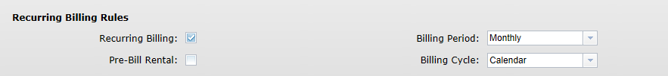

General - Recurring Billing Rules
This section provides fields for general rules for recurring billing on a contract.

Recurring Billing
Check this box to use recurring billing. Recurring billing can be engaged when a serialized or non-serialized unit is kept beyond its initial rental period/expected return. For example, if a customer rents a unit for a month and then needs to keep it for 2 additional months, recurring billing could kick in and bill for those additional rental periods as the contract comes up to the billing period.

Pre-Bill Rental
Check this box if your business routinely bills for rentals up front when the unit is checked out. Leave it unchecked to choose it as needed when the rental contract is processed.
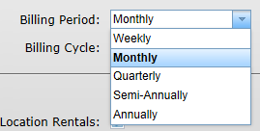

Billing Period
This drop-down menu determines when Rental billing/invoices are generated. Choices include Weekly, Monthly, Quarterly, Semi-Annually, and Annually. Choose the one that will be used to determine when the next billing should be initiated.
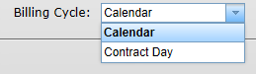

Billing Cycle
This drop-down menu offers 2 choices to specify when the billing date should be. Calendar means that the billing will occur on the first calendar day of the month, quarter, semi-annual, or annual period regardless of the actual day the rental started. Contract Day means that the billing will be based on the day the rental started, and will be incremented in calendar months or 28 day months for the month, quarter, semi-annual, or annual billing periods that follow. Choose the option that best fits your business.

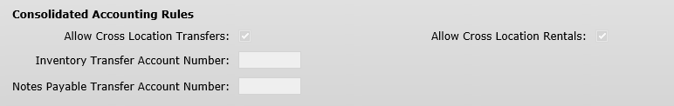

General - Consolidated Accounting Rules
This section provides fields for multi-location dealerships and preferences for transfers and rentals between locations. NOTE: If you are not a consolidated location, you will not see this section.

Allow Cross Location Transfers
When checked, this field allows the transfer of serialized units across locations. It then allows the units to be transferred from Inventory to Rental from the consolidated location to another eligible location. Leave the field unchecked if no units are to be transferred between locations.

Allow Cross Location Rentals
When checked, this field allows the rental of serialized units across locations. In this case, a unit from a location can be rented by another location. The revenue generated from the rental stays with the renting store while the cost or depreciation will be passed back to the location that owns it. Leave the field unchecked if no units are to be rented across locations.
Inventory Transfer Account Number
Enter the account number to be used for Inventory Transfer accounting, i.e. the accounting associated with a unit or part transferred from Inventory to Rental.

Notes Payable Transfer Account Number
Enter the account number to be used for Notes Payable Transfer accounting, i.e. the accounting associated when you are using the profits from a unit’s rental to pay off the cost of purchasing the unit.
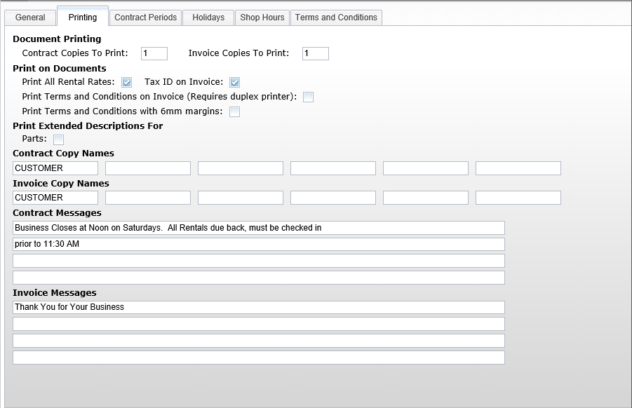

Field Definitions-Printing Tab
This section provides fields for printing preferences for rental contracts and invoices.

Document Printing
Set the number of copies to print here. Enter the number of copies for contracts and invoices.

Print on Documents
Choose the additional information to print on Rental invoices. Check the box for Print All Rental Rates to include all rental rates for the unit(s) being rented. Check the box for Tax ID on invoice to print the Tax ID from Enter Customer Information (ECI) on the Rental invoice.

Print Terms and Conditions on Invoice (Requires duplex printer)
Check this box to print the Terms and Conditions on the back of the Rental invoice. You must have a duplex printer to perform this operation. Leave the box blank to omit the Terms and Conditions from the invoice.

Print Terms and Conditions with 6mm margins
Check this box to print the Terms and Conditions on the Rental invoice with 6mm margins. Leave it blank otherwise.

Print Extended Descriptions For
Check the box to include the Extended Description for any parts sold on a Rental invoice.


Printing (cont.)

Contract Copy Names
For each contract copy selected to print, enter the name to print on the bottom of that copy (i.e. Customer, Accounting, File).

Invoices Copy Names
For each invoice copy selected to print, enter the name to print on the bottom of that copy (i.e. Customer, Accounting, File).

Contract Messages
Enter the text for the message to print on all contract copies. Each of the 4 lines will handle about 80 characters of message text.

Invoice Messages
Enter the text for the message to print on all invoice copies. Each of the 4 lines will handle about 80 characters of message text.
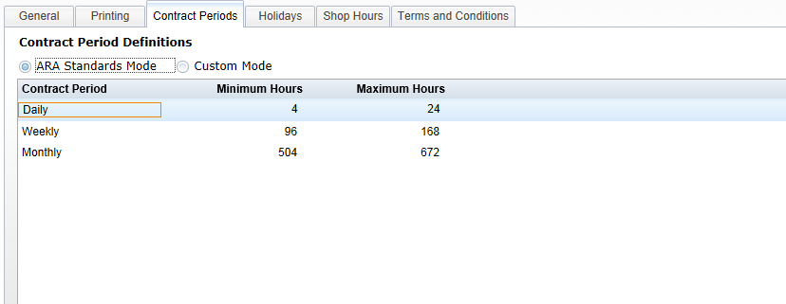

Contract Periods
For this portion of the defaults, choose from 2 modes: ARA Standards and Custom.

ARA Standards Mode
The ARA Standards mode selection uses the periods and definitions provided by the American Rental Association. These settings are not modifiable as they are preset when this choice is selected. They define the minimum and maximum hours for the 3 ARA rental periods. These minimums determine when the periods automatically become the next period. For example, notice that when 4 hours of rental have passed, it is considered a day’s rental. Likewise, when 4 rental days have passed, it rolls to a week. In a similar fashion, when 3 rental weeks have passed, it is considered a month.
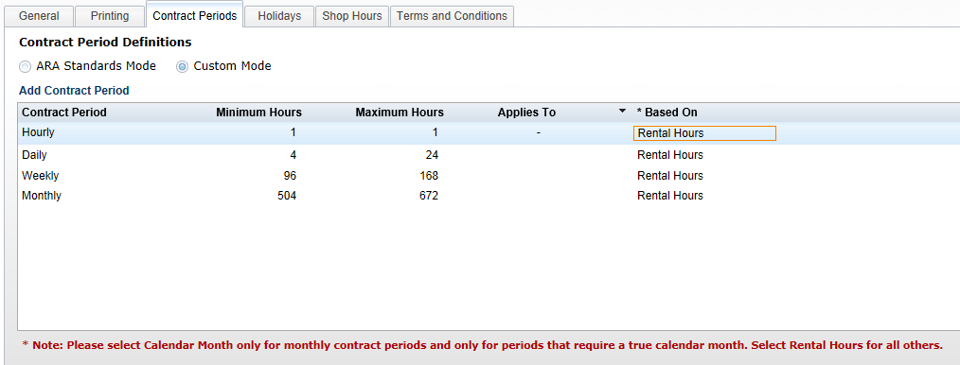

Custom Mode
In this mode, the setting for each contract period is configurable. The example above also includes an hourly contract period for a business that rents hourly.


Contract Periods-Custom Mode (cont.)
Add Contract Period
Click “Add Contract Period” to add a new period to the system.

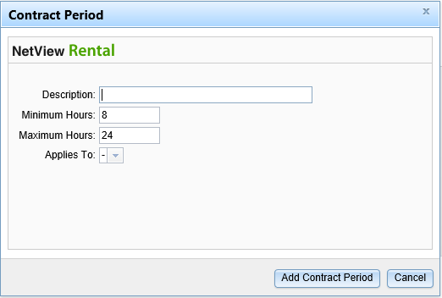

Description
Enter the period’s description here, i.e. Daily, Weekly, Monthly, etc.

Minimum/Maximum Hours
Enter the minimum and maximum hours that the contract period will cover in these fields.

Applies To
Use the drop-down menu here to specify if the period only applies to certain days of the week.

Custom Mode-Column Settings

Contract Period
This column lists the description you entered for the contract period.

Minimum/Maximum Hours
These columns can be set to how your business handles the automatic movement from one period to the next. In the above example, exceeding 4 hours moves to 1 day, exceeding 4 days moves to 1 week, and exceeding 3 weeks moves to 1 month.

Applies To
This column is available so that you may specify if the contract period applies only to specific days of the week. Leaving the column blank means it applies to any day of the week. You can sort the contract periods in ascending or descending order alphabetically by the days they apply to by clicking on the column header. An upward-pointing arrow means they are sorted in ascending order, while a downward-pointing arrow means they are sorted in descending order.
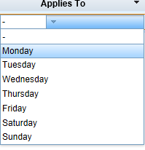

Based on
This setting is typically set to Rental Hours for most circumstances. One exception is for Calendar Month rentals, when it should be set to Calendar Month ONLY for the monthly contract period. You can sort the contract periods using this column by clicking on the column header. An upward-pointing arrow means they are sorted in ascending order (Calendar Month first, then Rental Hours), while a downward-pointing arrow means they are sorted in descending order (Rental Hours first, then Calendar Month).
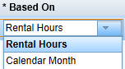
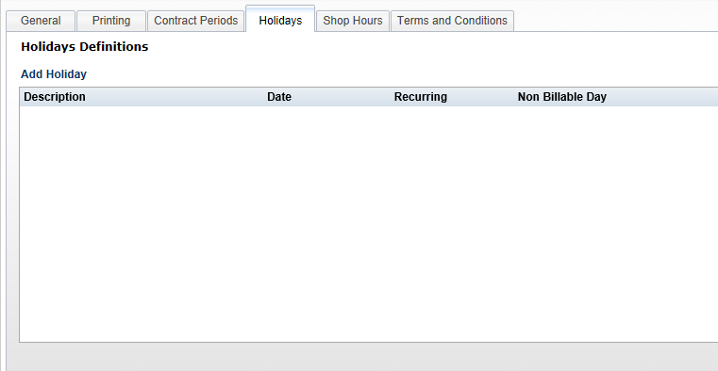

Holidays
This portion of the defaults is used to define holidays where rent is not likely to be charged. For example, if your business does not charge rent on Thanksgiving or Christmas, even when the unit is out, you could define that here.

Add Holiday
Click on Add Holiday to add one.
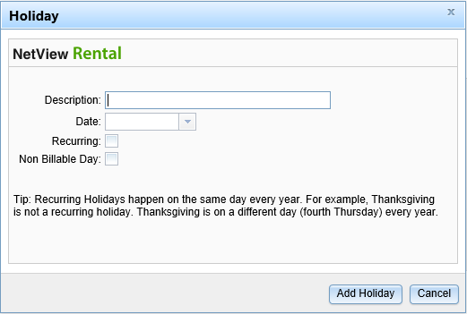

Description
Fill in the name of the holiday.

Date
Type in the date of the holiday (mm/dd/yyyy) or click on the arrow to choose the date from a calendar.
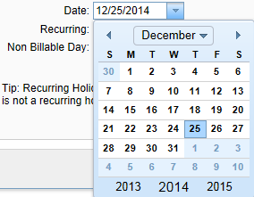

Recurring
Check the box if the holiday is ALWAYS on the same day each year. For example, Christmas is a recurring holiday as it always falls on December 25. However, Thanksgiving is not as it falls on the fourth Thursday of November.

Non Billable Day
Check this box if the holiday should not be billed.
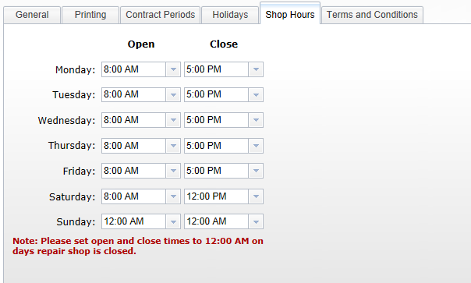

Shop Hours
Define the hours the Service department is open. These hours are used when the Required Service fields are active in Rental Class Maintenance (RCM). Set the hours for each day of the week. If you are not open, set the Open and Close times to 12:00 AM.
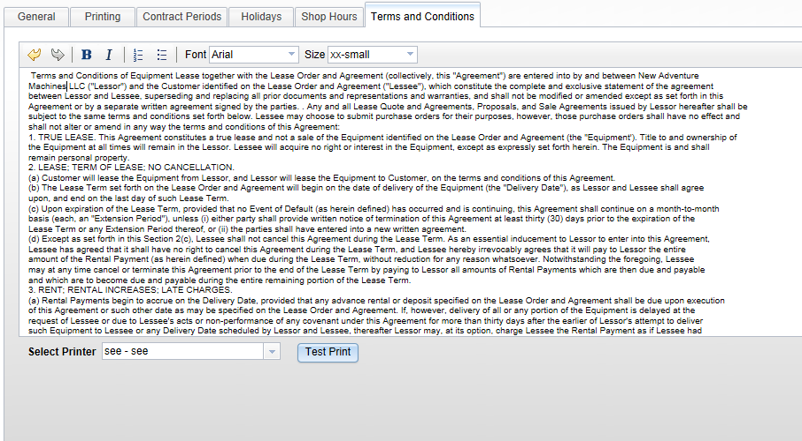

Terms and Conditions
This section holds the text of the Terms and Conditions that can optionally appear on the back of the invoices and contracts. It supports Copy and Paste if you have electronic copy, or may simply be typed.
The toolbar on the top has buttons for Undo, Redo, Bold, Italic, Numbering, Bullets, Font, and Size.
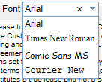 The font selection has a drop-down menu with several choices.
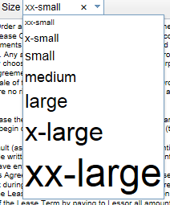 The size selection has a drop-down menu with several choices.
You can also generate a test print using the Test Print button at the bottom of the screen.

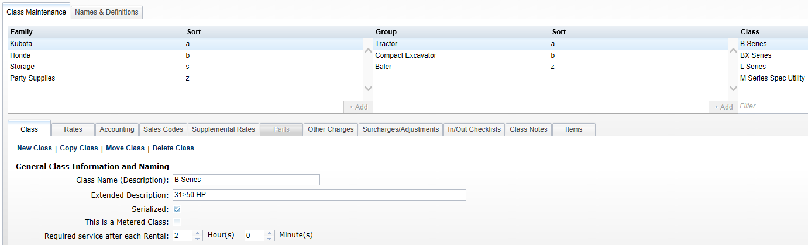
The Rental Class Maintenance screen houses two types of information: Definitions of the Family/Group/Class structure, and Names & Definitions for various components within the Rental System. These definitions are grouped together in tabs for easier navigation. To access this function, select the following from the menu:
Rental / Rental Class Maintenance
Or type RCM in the Shortcuts Bar

Names and Definitions
This section defines the names for Rate Types and Supplemental Types, plus the Other Charges and Surcharges/Adjustments, that can be used in any Family/Group/Class structure you create.

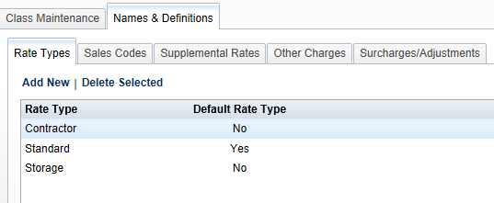

Names & Definitions-Rate Types
This list identifies the different rates types you will use in the Rental System. There can be many or few here, depending on how your business in structured. For example, you may have just two rates: Standard and Preferred. Other businesses may have many variations: Standard, Walk-In, Contractor, Preferred, Long Term, Special, etc.

Edit an existing rate
Simply double-click on the Rate Type name or Default Setting. Make your changes, and when you leave that field, the changes are saved.

Delete an existing rate
Highlight the desired choice and click on Delete Selected to remove it.

Add a new rate
Click on Add New to display this entry box.
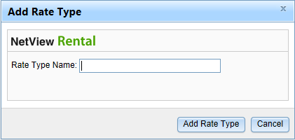
Type in the name for the Rate Type and click on the Add Rate Type button. Once it has been added, you can identify it as the default rate if necessary by clicking on that column of your new rate.

Names & Definitions - Sales Codes

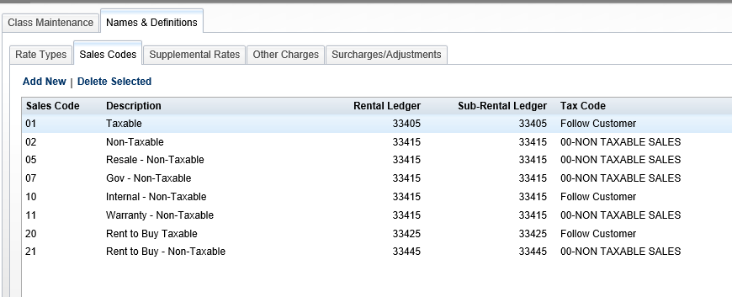

Click Add New to create a new Sales Code reference.
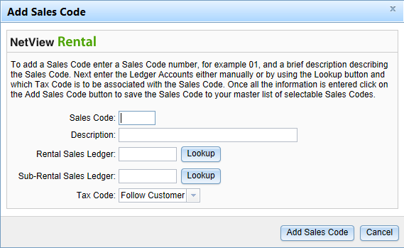

Sales Code
Fill in the numeric Sales Code here. The sales codes need to represent the ones presently used on customers in ECI. Some typical ones might include 01-Customer Rental Taxable, 02-Customer Rental Non-Taxable, 07-Govt Rental Non-Taxable, and 10-Internal Rental Non-Taxable.

Description
Fill in a description of the Sales Code.

Rental Sales Ledger
Identify the G/L account when the Rental Income should go. Type in the account number or use the lookup button to find it.

Sub Rental Sales Ledger
Identify the G/L account when the Sub Rental Income should go. A Sub Rental is a replacement unit from an outside source. Type in the account number or use the lookup button to find it.

Tax Code
This field lets you set how the sales tax on the class can be handled.
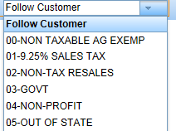
Choose Follow Customer if the tax on the rental will follow the customer’s tax status. Otherwise, choose a tax code from the drop-down menu to set its taxable nature.

Click on “Add Sales Code” to add the record.

Edit an existing Sales Code
You may double click on Description, Rental Ledger, Sub-Rental Ledger, or Tax Code to change the value in that field.

Delete an existing Sales Code
Highlight the sales to be deleted and click on Delete Selected to remove it.
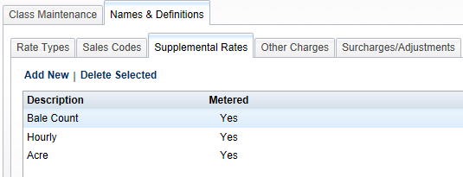

Names & Definitions-Supplemental Rates
This list identifies any additional rates you will use in Rental. Typically, these are rates that supplement or are in addition to the primary rental rate. For example, you might add supplemental rates for Bale Counts, Hour Meter, Acre Count, etc.
To edit an existing rate, simply double-click on the Supplemental Description or Metered setting. Make your changes, and when you leave that field, the changes are saved.
To delete a rate, highlight the desired choice and click on Delete Selected to remove it.
To add a new rate, click on Add New to display the entry box.
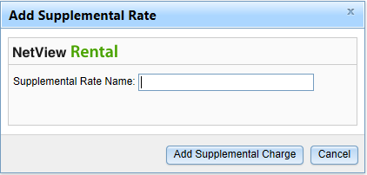
Type the name for the Supplemental Rate and click on the Add Supplemental button. Once it has been added, you can edit if it is metered by clicking on that column of your new supplemental rate.
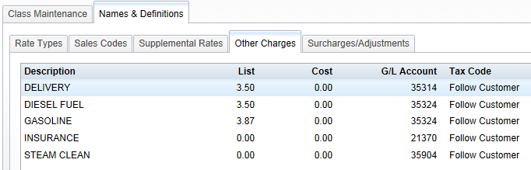

Names & Definitions-Other Charges
This list shows Other Charges that can be added to any of the Rental Classes. It reads from available entries tagged for Rental in Other Charge Maintenance (OCM). All the information—Description, List, Cost, G/L Account, and Tax Code—is read from OCM.

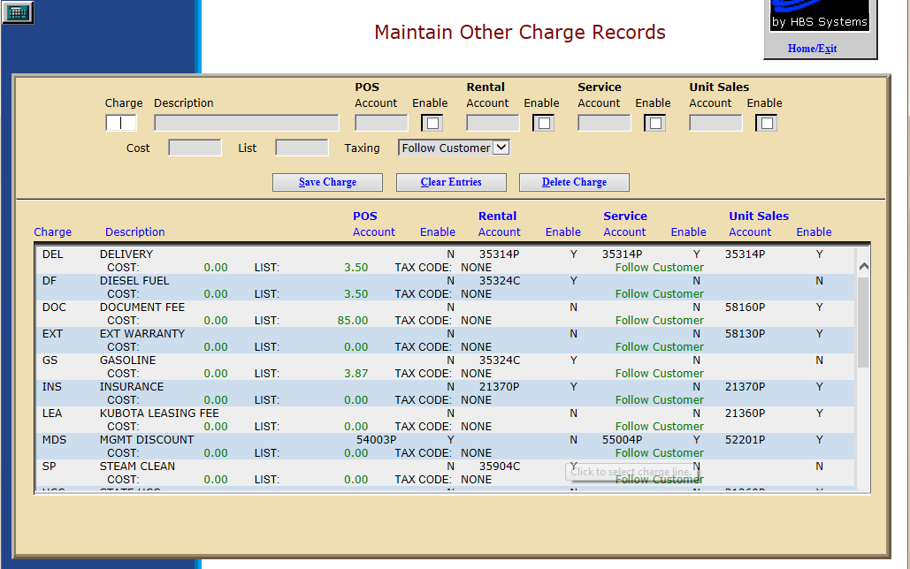

Charge
This is a 3-character code for the other charge defined. It is used for record maintenance and does not appear on the invoice.

Description
This field holds the description of the other charge that will print on the invoice.



Names & Definitions-Other Charges (cont.)



Account
This field holds the General Ledger account that will receive the amount for this method of payment. Click on the Enable field to its right to activate it. The fields that are ACTIVE at this time are Service and Unit Sales. Choose the appropriate General Ledger account for each invoicing program for this method of payment.

Enable
Click on this field to the right General Ledger account to use it in the identified invoicing screen.

Cost
This field can hold the cost of the Other Charge. It should only be filled in if the cost is ALWAYS the same.

List
This field can hold the selling price of the Other Charge. If the price of this Other Charge is ALWAYS the same, it could be entered here.

Taxing
This field lets you set how the sales tax on the other charge can be handled.
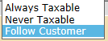
Choose Always Taxable if it will be always taxable and choose the Tax Code that applies.
Choose Never Taxable if it never is subject to sales tax and choose the Tax Code that applies.
Choose Follow Customer if the tax on the other charge will follow the customer’s tax status.
Press the Save button (Alt S) to save the record.
All entries in OCM that are tagged as Rental will display in the Other Charges tab in Names and Definitions in RCM.
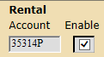
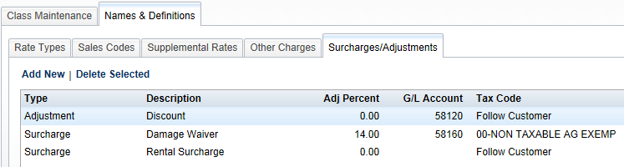

Names & Definitions-Surcharges/Adjustments
This section is used to define any percentage-based surcharges or adjustments to the rental contract. For example, you might add Adjustments for Discounts, Weather Delay, Maintenance, etc. The adjustments can add or deduct from the charges on the invoice based on a percentage of any portion of the items being billed. Likewise, the surcharge is percentage-based and is selectable by any portion of the items being billed. Examples of a surcharge would include Damage Waiver, Insurance, or a state-imposed Rental Surcharge.

Edit an existing adjustment or surcharge
Simply double-click on the field to be changed. Make your changes, and when you leave that field, the changes are saved.

Delete an adjustment or surcharge
Highlight the desired choice and click on Delete Selected to remove it.

Add a new adjustment or surcharge
Click on Add New to display the entry box.
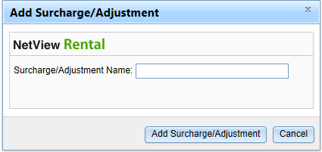
Type the name for the Surcharge/Adjustment and click on the Add Surcharge/Adjustment button. Once added, you can fill in the remaining details on the line where it shows: Type, Description, Adj Percent, GL Account, and Tax Code.

Type
Double-click in this field to choose Surcharge or Adjustment.
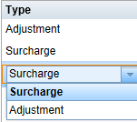

Description
Double-click in this field to edit the name for the surcharge/adjustment.

Adj Percent
Double-click in this field to enter the percentage (+ or -). You can leave it blank if it varies.

GL Account
Double-click in this field to enter or look-up the GL account to receive this surcharge/adjustment.

Tax Code
This field lets you set how the sales tax on the surcharge/adjustment can be handled.

Choose Follow Customer if the tax on the surcharge/adjustment will follow the customer’s tax status. Otherwise, choose a tax code from the drop-down menu to set its taxable nature.

Rental Family/Group/Class structure
There are three layers of structure to organize your serialized and non-serialized rental units. Listed below are several examples of this structure to give you some ideas how they might work for you.
Example 1

Family Group Class
Ag Tractor 0-40 HP
Ag Tractor 41-59 HP
Ag Tractor 60-99 HP
Ag Tractor 100-139 HP
Ag Tractor 140+ HP
Ag Baler Square Baler
Ag Baler Round Baler
Construction Crawler Dozer
Construction Crawler Loader
Construction Crawler Crane
Construction Forklift Counterbalance
Construction Forklift Reach
Example 2

Family Group Class
Kubota Tractor B Series
Kubota Tractor BX Series
Kubota Tractor L Series
Honda Generator 100 HP
Honda Generator 100+ HP
NH Baler Round
NH Baler Square
Example 3

Family Group Class
Party Supplies Tents 20x20
Party Supplies Tents 30x20
Party Supplies Chairs Wood
Party Supplies Chairs Metal
L&G Handheld Chainsaw
L&G Handheld Edger
L&G Handheld Blower
L&G Mower Walkbehind
L&G Mower Riding
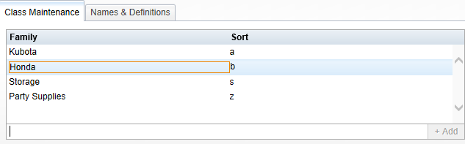

Class Maintenance - Family
Begin the structure by defining the Family. Type the Family Name on the blank line provided below the listed names and click the +Add button on the right. The name you entered now shows in the left column. The Sort column gives you the ability to have the Family Names sort in an order other than alphabetical. Type in a character to choose its position in the desired sorting order.
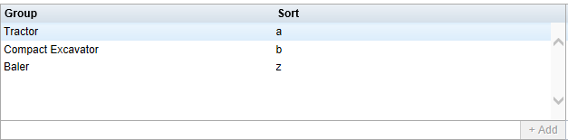

Class Maintenance - Group
The next step in the structure is the Group. Type the Group Name on the blank line provided below the listed names and click the +Add button on the right. The name you entered now shows in the left column. The Sort column gives you the ability to have the Group names sort in an order other than alphabetical. Type in a character to choose its position in the desired sorting order.
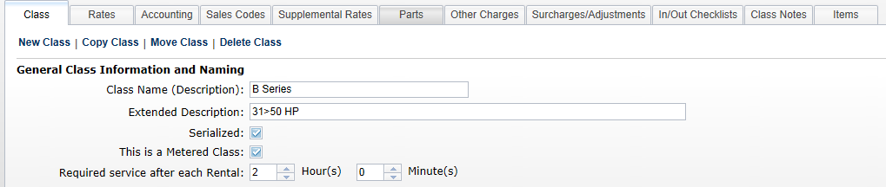

Class Maintenance - Class
The third and final layer in the structure is the Class. This definition holds all the specifics about that Class in Rental. Numerous tabs organize this information for each Class.

Add a Class
To create a new class, click the New Class button on the Class tab.
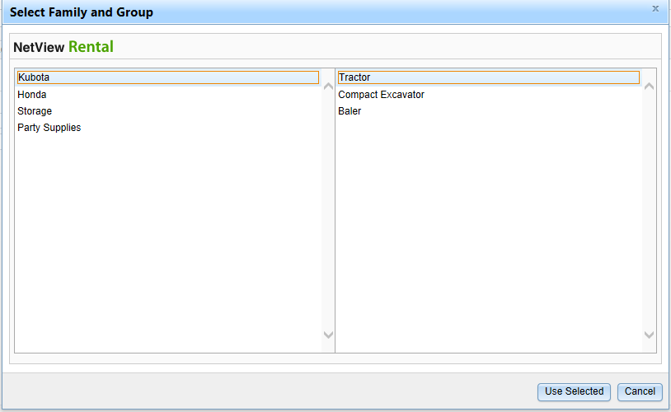
Click on the Family and Group where it belongs, and click the Use Selected button at the bottom of the box.



Class Maintenance–Class-General Class Information and Naming

Class Name
Fill in the name in the Class Name field.

Extended Description
Use this area to provide further information about the Class.

Serialized
Check this box if the unit is serialized. Serialized units are found in Units, while non-serialized items are classified as Rental Parts.

This is a Metered Class
Check this box when the Class has a meter. The meter may or may not be used to determine the rental rate.

Require Service
These two fields can be used to indicate that the unit needs to be in the shop when it returns from a rental. Use the Hours and Minutes settings to indicate how long it needs to be there.

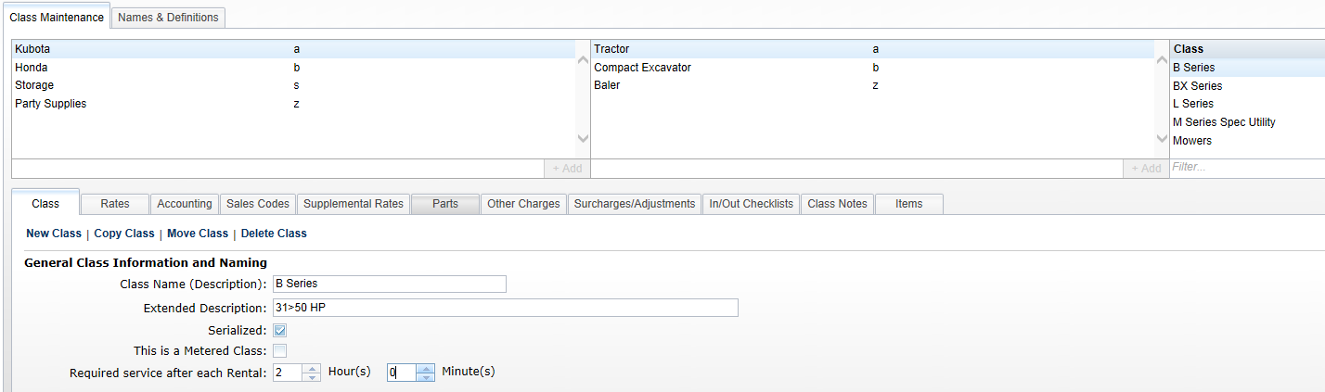

Class Maintenance–Class-Copy Class
Select the Class from within the group and family it belongs to, and click on Copy Class.

Then verify where it will be place from the Family and Groups shown.
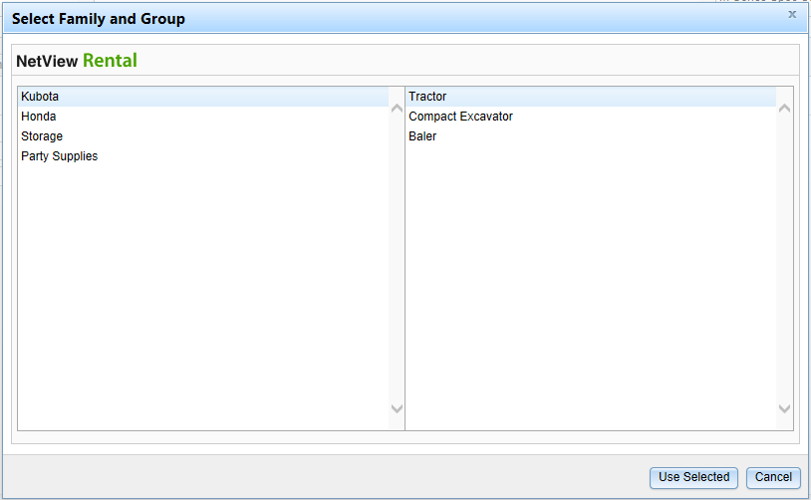
Click on Use Selected and a copy of the selected class is created.
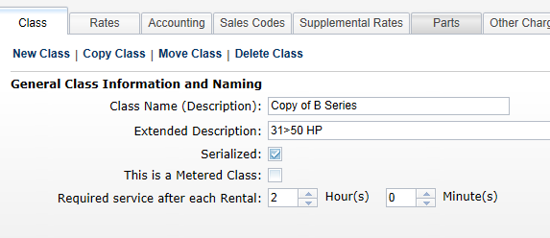
The process copies all associated information from all tabs of the copied class. Change the Class Name of the copy to the name of the new class and then adjust settings in the tabs as needed.

Class Maintenance–Class-Move Class
Identify the class to move by highlighting it.
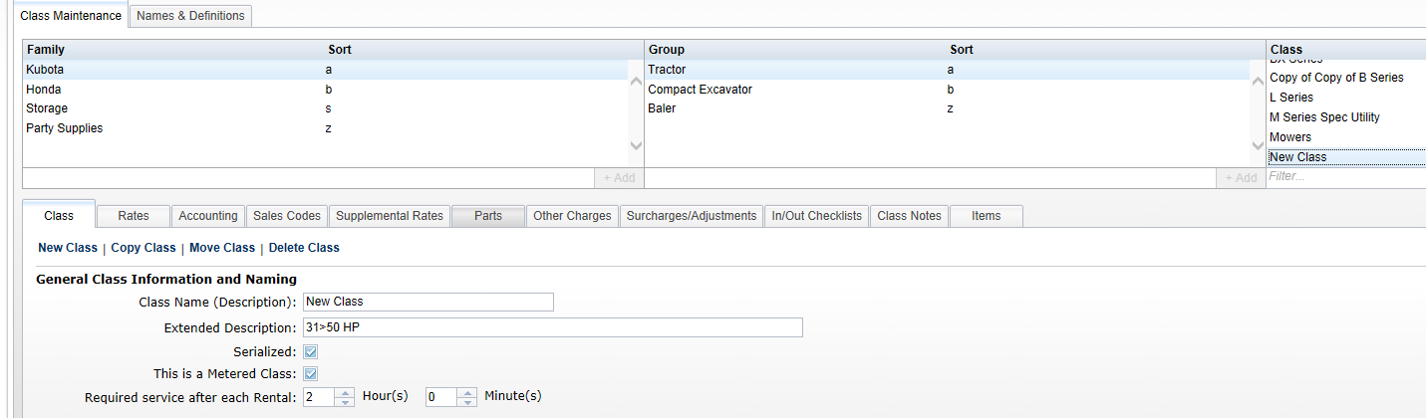
Click on Move Class to initiate the process.
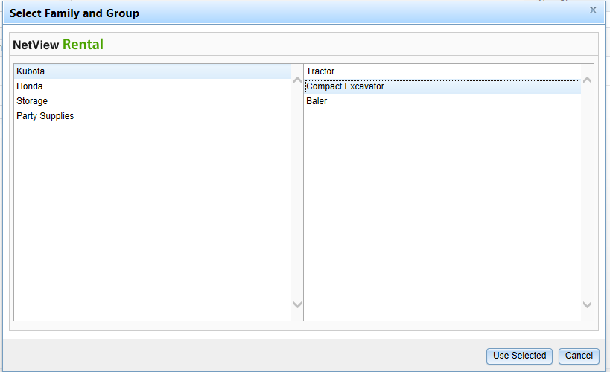
Choose the new place for the class from the list of Family and Group definitions. Click Use Selected to move the class to its new home.
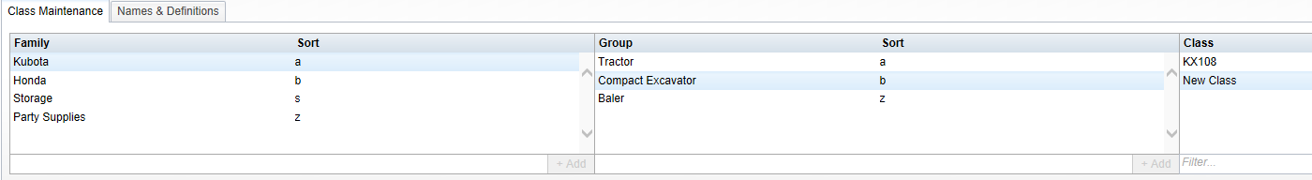



Class Maintenance–Class-Delete Class
Highlight the class to be deleted. Click on Delete Class.
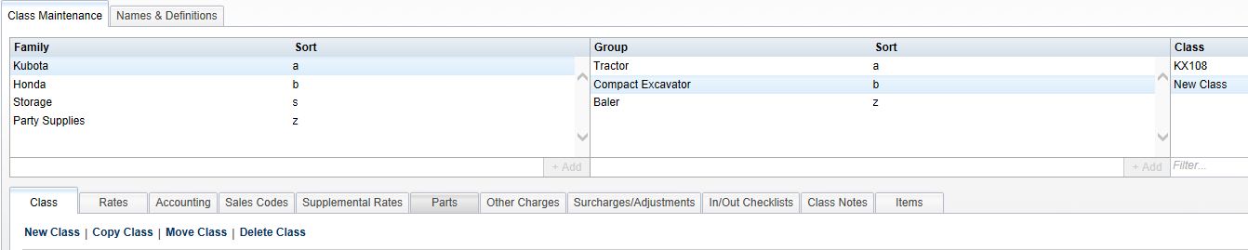
Confirm that you want to delete the class.
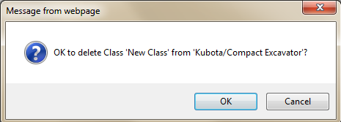

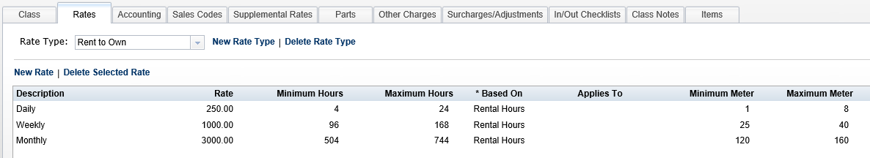

Class Maintenance - Rates
This tab holds the rates for the different rental periods.

Rate Type
This drop-down menu shows all the rate types currently selected for this class. To add another, click on New Rate Type, choose one from the list, and click on Add Selected. This list is generated from the selections added in Names and Definitions.
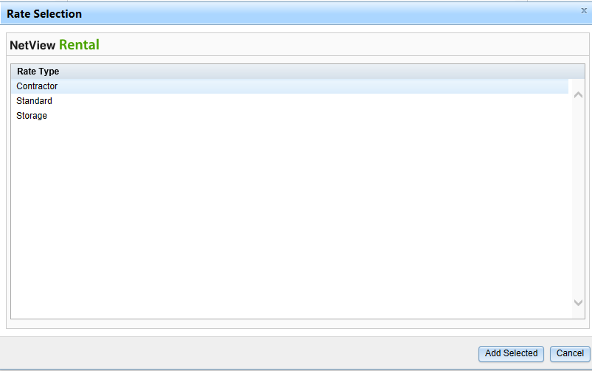

Delete Selected Rate Type
Click on a rate type and then click Delete Selected Rate Type to remove it from this class.



Class Maintenance - Rates (cont.)

Add a Rate
Click on New Rate to add one.
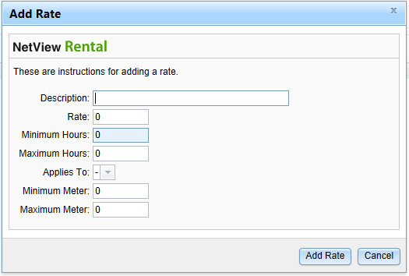

Description
Fill in the description of the rate.

Rate
Fill in the rate for this record.

Minimum Hours/Maximum Hours
Enter the minimum and maximum hours for this rate. For an hourly rate, the minimum and maximum would be 1. For others, the fields would hold a range of numbers.

Applies to
If the rate applies to a specific day of the week, choose it from the drop-down menu.

Minimum Meter/Maximum Meter
Enter the minimum and maximum meter for this rate, if applicable. These fields might be used for a metered rental rate.

Click “Add Rate” to save the info.

Delete Selected Rate
Click on a rate and then click Delete Selected Rate to remove it from this class/rate type.

Rate Examples

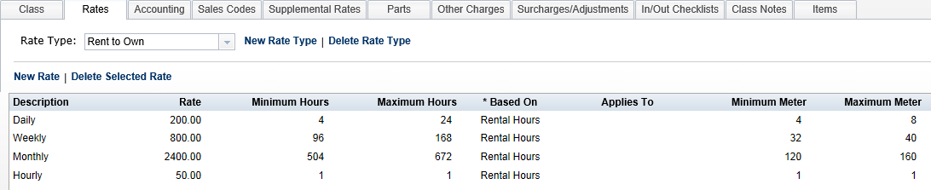

This setup example is for when the meter determines the rate.
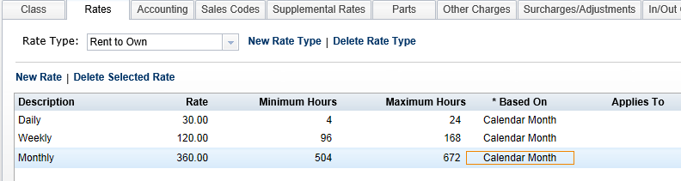
This setup example is for a rate is based on a calendar month billing, i.e. storage buildings, rental properties, etc.
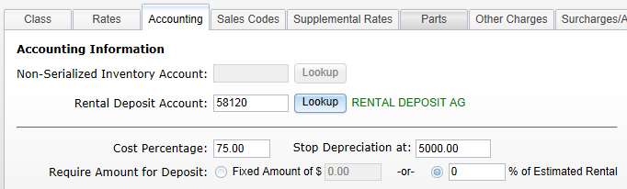

Class Maintenance - Accounting Information
This tab holds information about some accounting preferences.

Non-Serialized Inventory Account
This field holds the GL account number for any non-serialized items for this class. These are items that will be rented from Parts, so it is likely that the account number will be in the 14xxx series. You can type in the account number or press the Lookup button to search for it.

Rental Deposit Account
This field identifies the GL account where deposits will be placed for units/items in this rental class. You can type in the account number or press the Lookup button to search for it.

Cost Percentage
This field is used for depreciation based on the amount of rental income for serialized units. When a percentage is entered here, it is factored against the rental income billed on the invoice and that percentage becomes the “cost” of the transaction. The journal that is created with this percentage will debit (+) the cost of sale and credit (-) the inventory of the serialized unit.

Stop Depreciation at
This field holds a stopping point for depreciation. The system will continue to apply the credits of depreciation against the rental unit until it reaches the amount entered here. For example, if 1.00 is placed in this field, the system calculates and applies depreciation credits based on the amount of rental income until the value of the unit reaches the amount shown.

Require Amount for Deposit
A required deposit can be defined as a fixed amount or as a percentage of the estimated rental. Choose the appropriate setting, and enter either a fixed amount or the percentage to calculate the deposit amount.

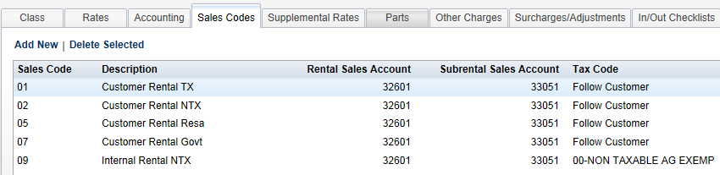

Class Maintenance - Sales Codes
Click on the Sales Codes tab next and fill in the necessary information.

Add a New Sales Code
Click Add New to create a new Sales Code reference.
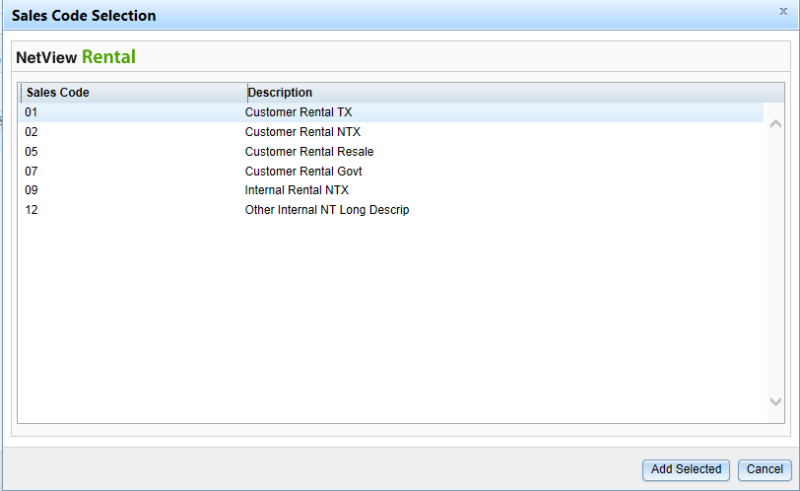
Highlight the Sales Code and click Add Selected to add to this class. Once all are added, click Cancel to leave this function.

Delete a Sales Code
Highlight the Sales Code and click Delete Selected to remove that sales code from this class.

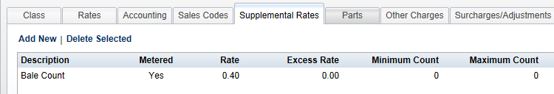

Class Maintenance-Supplemental Rates
This tab holds info about any supplemental rates for this class/rate type. The supplemental rates typically are in additional to the rental rate for the class.

Add New Supplemental Rate
To add another, click on Add New, choose one from the list, and click on Add Selected. This list is generated from the selections added in Names and Definitions.
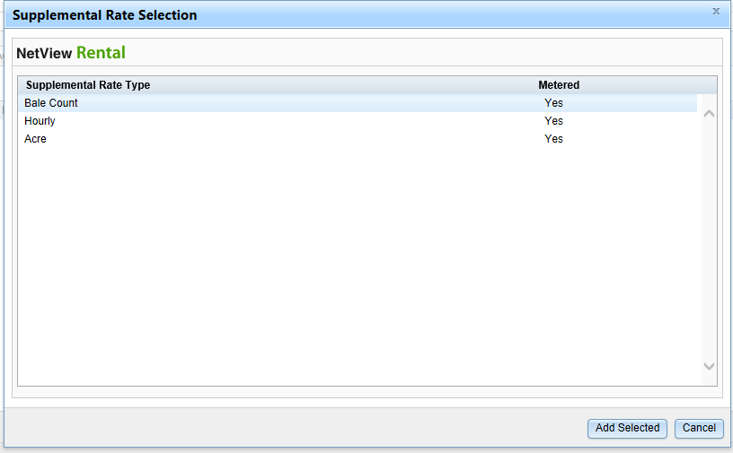

Delete Selected
Click on a supplemental rate and then click Delete Selected to remove it from this class/rate type.

Edit Existing Supplemental Rate
Click on any of the fields (except Description and Metered) of an existing rate to edit the information.
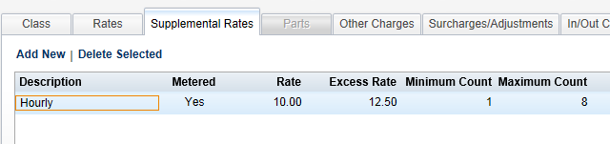

Rate
Enter the supplemental rate here. The value can hold numbers with 2 decimal places.

Excess Rate
Enter the excess rate here. This rate is used when a rental continues beyond the value in the Maximum Count.

Minimum Count/Maximum Count
Enter the minimum and maximum count for this supplemental rate, if there is an excess rate. If the rental exceeds the maximum count, the excess rate is then charged on the rental.
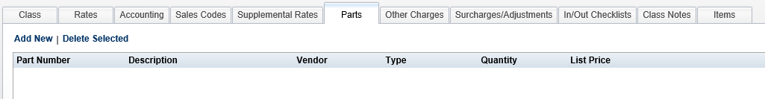

Class Maintenance - Parts
The Parts tab is available in each dealership location. For multi-location dealerships, the Parts tab is not accessible in the Consolidated location. This tab holds information about any parts that need to be sold when a unit from this class is rental. These can represent consumable items that are necessary for the use of this equipment (i.e. chainsaw oil, tie downs, chain, hitch ball, tent stakes, etc.)

Add a Part
Click on Add New.
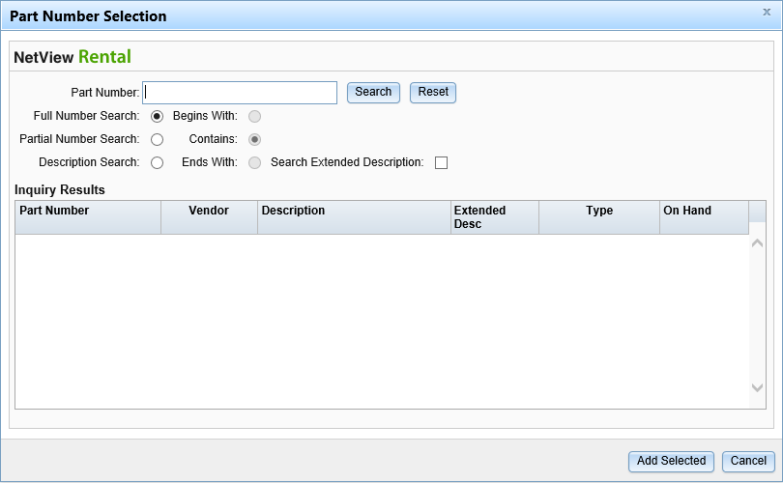

Part Number
Enter the part number or use any of the search options listed.

Full Number Search
Click here to do a full number search and type in the complete part number.

Partial Number Search
Click here to do a partial part number search. You must also choose which portion of the part number to search: Begins With, Contains, or Ends With.

Description Search
Click here to search by the part number description. You can optionally search the Extended Description at the same time.

Begins with/Contains/Ends With
These fields are used when a partial number search is done. Click on the one you want to use.

Search Extended Description
Click here to search the extended description field when doing a description search.
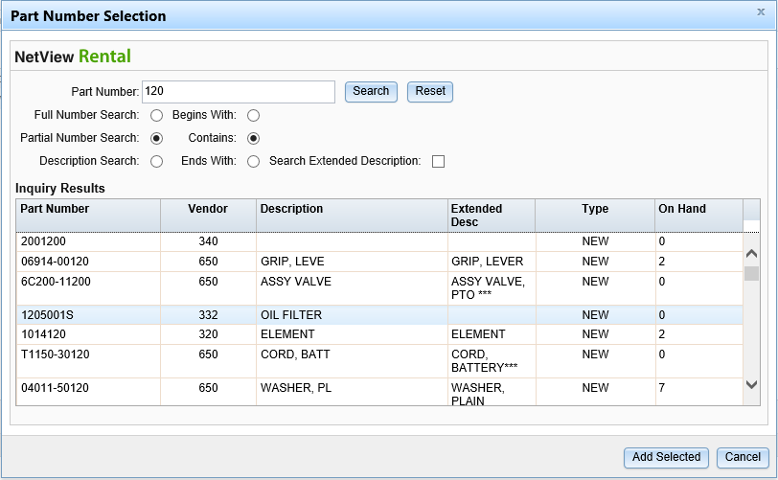
Highlight the part and click Add Selected to put it on the Parts list for this class.
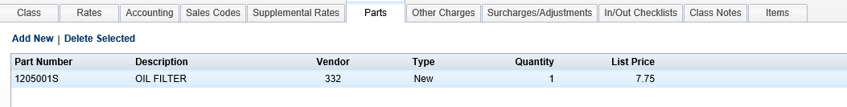
You may double-click on the Quantity to change it as needed.

Delete Selected
Click on a part number and then click Delete Selected to remove it from this class/rate type.

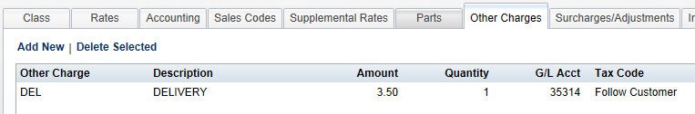

Class Maintenance - Other Charges
Use this section to include any Other Charges that belong to the rental class/rate type.

Add an Other Charge
Click on Add New to add an Other Charge that has been tagged for Rental.
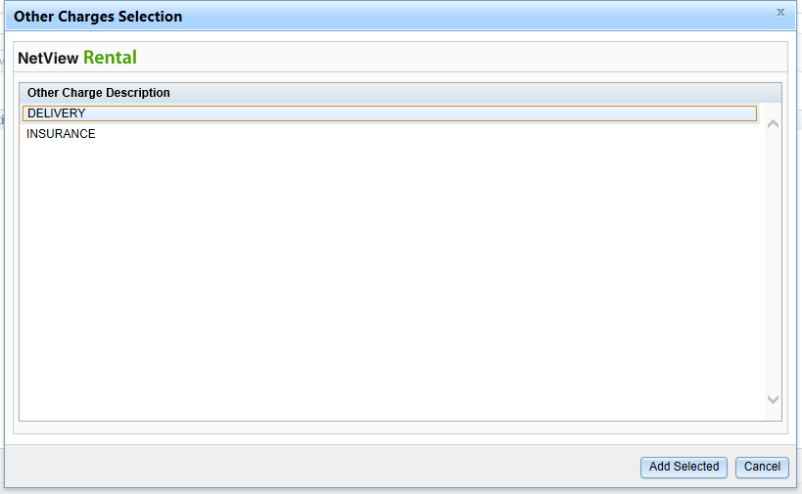
Highlight the other charge and click Add Selected.

Delete Selected
Click on an Other Charge and then click Delete Selected to remove it from this class/rate type.

Edit Other Charges
You may edit the Description, Amount, Quantity, and Tax Code to adapt the Other Charge to this rental class/rate type.
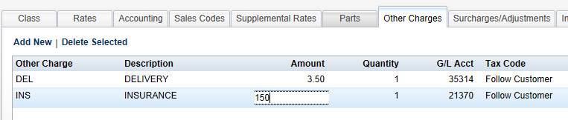
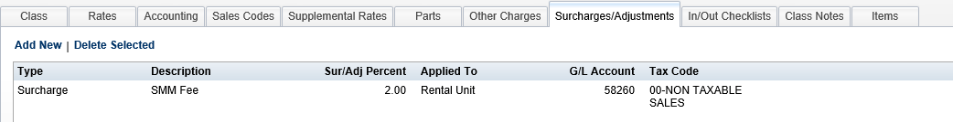

Class Maintenance - Surcharges/Adjustments
Use this section to include any Surcharges or Adjustment that are needed for this rental class/rate type.

Add a Surcharge or Adjustment
Click on Add New to add a Surcharge or Adjustment that has been tagged for Rental.
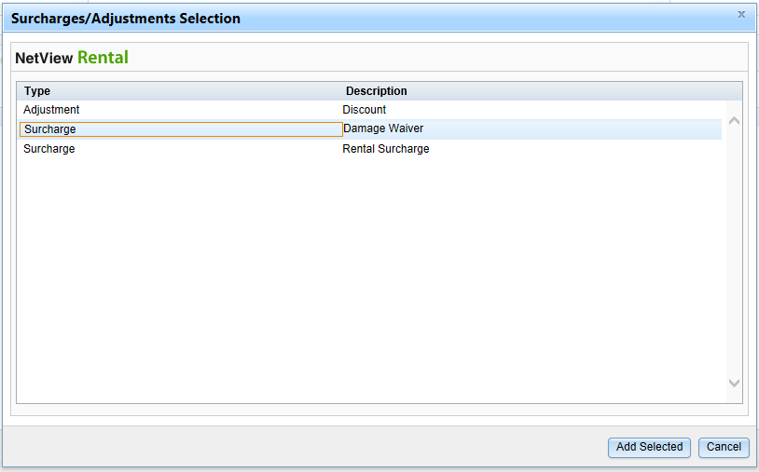
Highlight the Surcharge or Adjustment and click Add Selected. You may edit the addition by double-clicking the various fields on the line.

Delete Selected
Click on a Surcharge or Adjustment, and then click Delete Selected to remove it from this class/rate type.


Class Maintenance - Surcharges/Adjustments (cont.)

Edit Surcharges/Adjustments
You may edit the Description, Sur/Adj Percent, Applied to, GL Account, and Tax Code to adapt the Surcharge or Adjustment to this rental class/rate type.
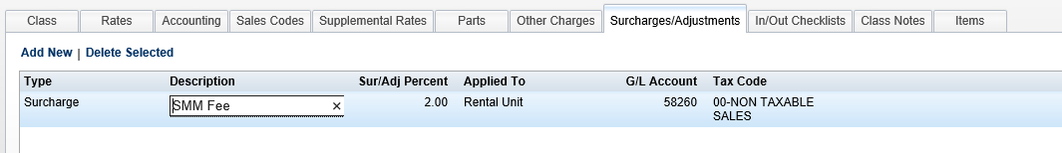
The Applied to Column let you specify which part of the rental invoices is subject to the percentage-based Surcharge or Adjustment. Double-click on the line field to select the desired item(s): Rental Item, All Parts, or All Other Charges. Click OK once you’ve made your selection.
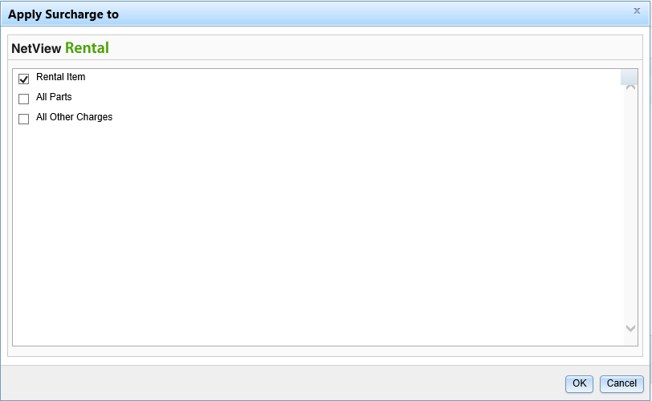

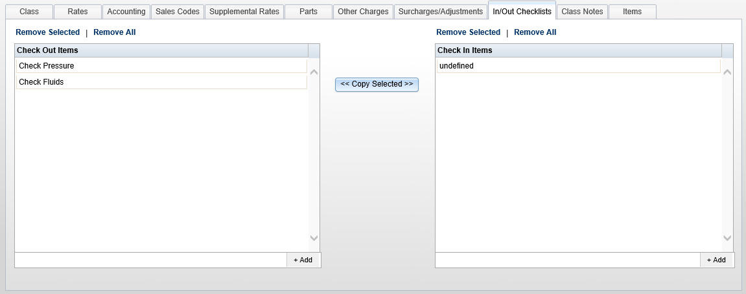

Class Maintenance - In/Out Checklists
This tab provides the option to create lists of tasks that need to be done when the unit is checked out on a rental, and also a different list when the unit is checked back in as it is returned.

Add Task
The last line of the Check Out Items or Check In Items list is the place to add tasks to the list. Simply type in the desired task and click the +Add button on the right. If you want the newly created task to be in different position, click on it and hold it down while you drag it to the preferred position, then release your hold.

Remove Selected
Highlight one or more of the tasks on the Check Out or Check In list, and click Remove Selected to clear them from the list.

Remove All
Click Remove All to clear ALL items on the Check Out or Check In list.

Copy Selected
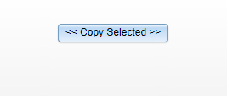

This button, shown between the Check Out List and the Check In List, allows you to copy items from one list to the other. Highlight the items on one list or the other and press the button to copy them to the other list.
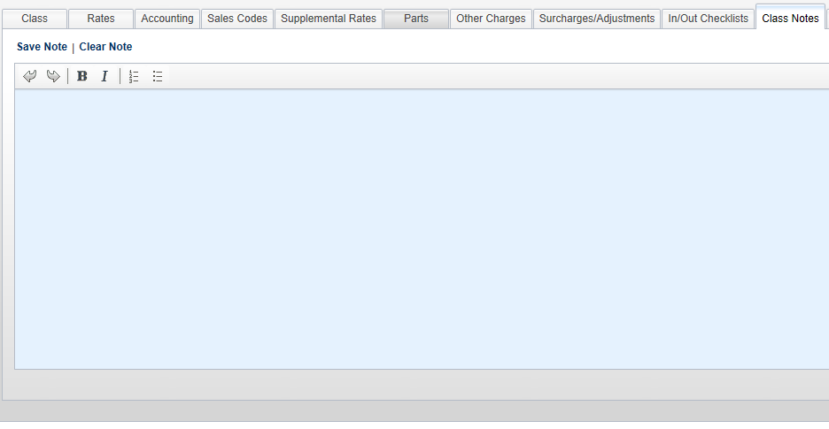
Class Maintenance-Class Notes
This section provides space for notes for this class of rentals. These notes will appear on any items for the class. It could be maintenance items that the customer is responsible for, reminders about how some feature on the rental unit works, or other information to be shared with the customer. The toolbar on the top has buttons for Undo, Redo, Bold, Italic, Numbering, and Bullets.

Save Note
Click Save Note when all text has been entered for the Class Note.

Clear Note
Click Clear Note to remove all text in the Note tab.
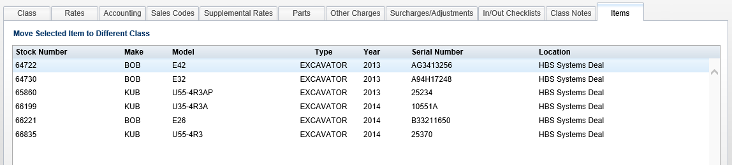

Class Maintenance – Items
This tab shows a list of the rental units that belong to this class. The information includes the stock number, make, model, type, year, serial number, and location.

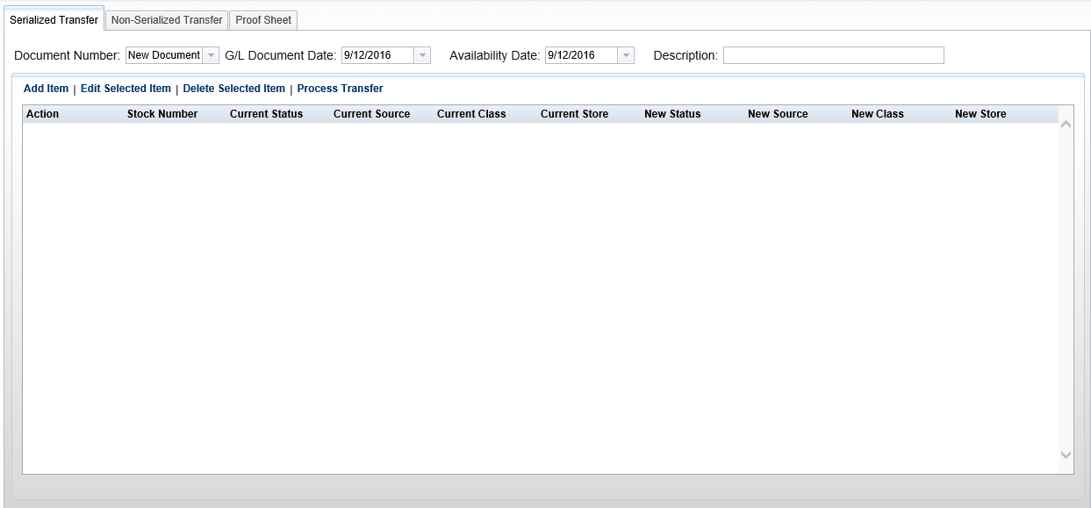
Anytime you need to rent a unit, serialized or non-serialized, that unit must be in Rental. Access the screen for this process by selecting the following from the menu:
Rental / Rental Transfer Assets
Or type RTA in the Shortcuts Bar
From this screen, you can perform a number of transfer variations:

- Transfer a unit to Rental
- Transfer a unit from Rental back to New
- Transfer a unit from Rental back to Used
- Transfer a part to Rental
- Transfer a Rental part back to Parts

Both the Serialized Transfer tab and the Non-Serialized Transfer tab use the same processes for adding, editing, deleting, and processing transfers. The sample process detailed below will be shown in the Serialized Transfer tab.


Adding Transfers

Document Number
Choose New Document to begin a new transfer or choose a document number from the drop-down menu to review an existing unprocessed transfer.

GL Document Date
Enter the date to be used for the accounting transaction created from the transfer. It must be a date in an open accounting period. The current date appears as a default.

Availability Date
Enter the date the unit will first be available for rental here. No rental activity can occur prior to the dated noted here. It does NOT have to be in an open accounting period. The current date appears as a default.

Description
Fill in a brief description of the transfer.

Once that information is completed, click Add Item to continue.

After clicking “Add Item,” the following window will open:
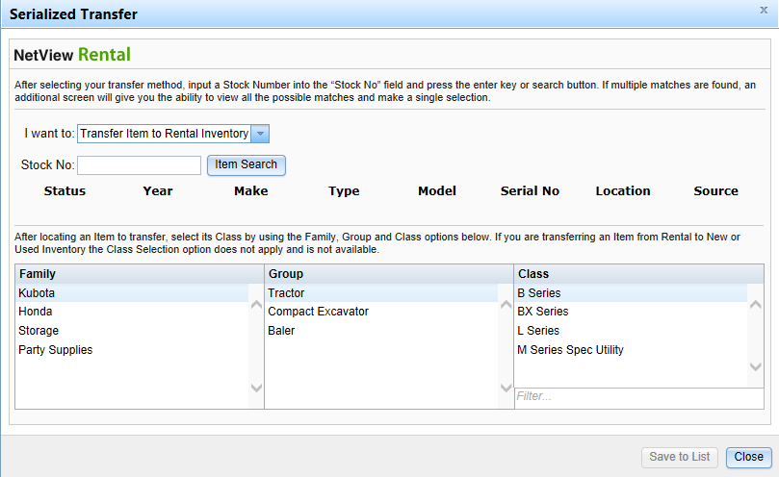
Choose the type of transfer from the drop-down menu.
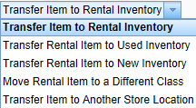
Enter the stock number to transfer or search for it.
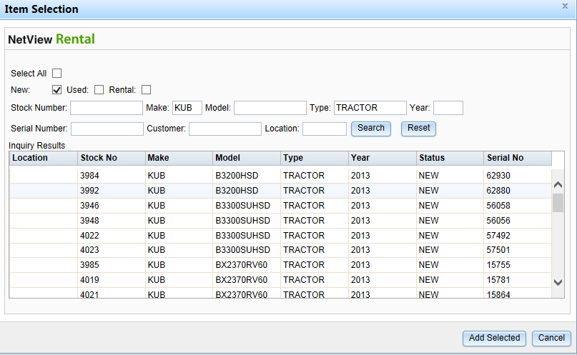
Find the unit, click on its line, and click on Add Selected to include it in the transfer.


Adding Transfers (cont.)
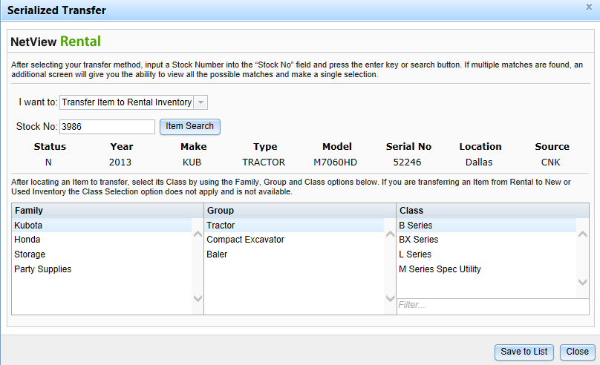
Click Save to List to add it to the transfer. Click Close when all units have been added to the transfer.
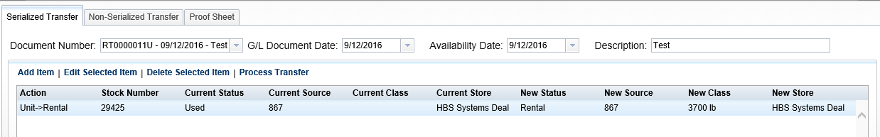

Edit Selected Item
This function lets you adjust the Family, Group, or Class of the transfer units. Highlight the unit to be changed, click on Edit Selected Item, and highlight new Family, Group, and/or Class. Click Save to List to finalize your changes.

Delete Selected Item
Highlight the unit to remove and click Delete Selected Item.

Process Transfer
Click Process Transfer to finalize the transfer and create the G/L entry.
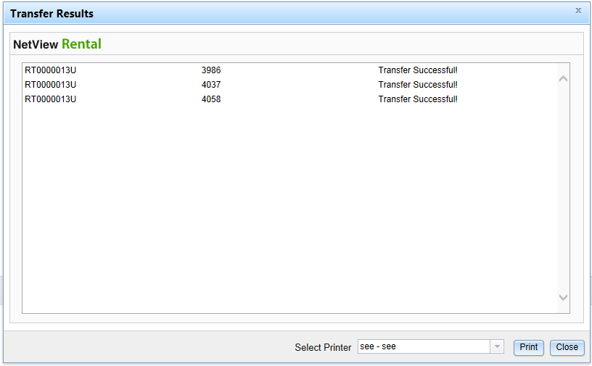
Proof Sheet
Click the Proof Sheet tab to view the entries before they are posted.
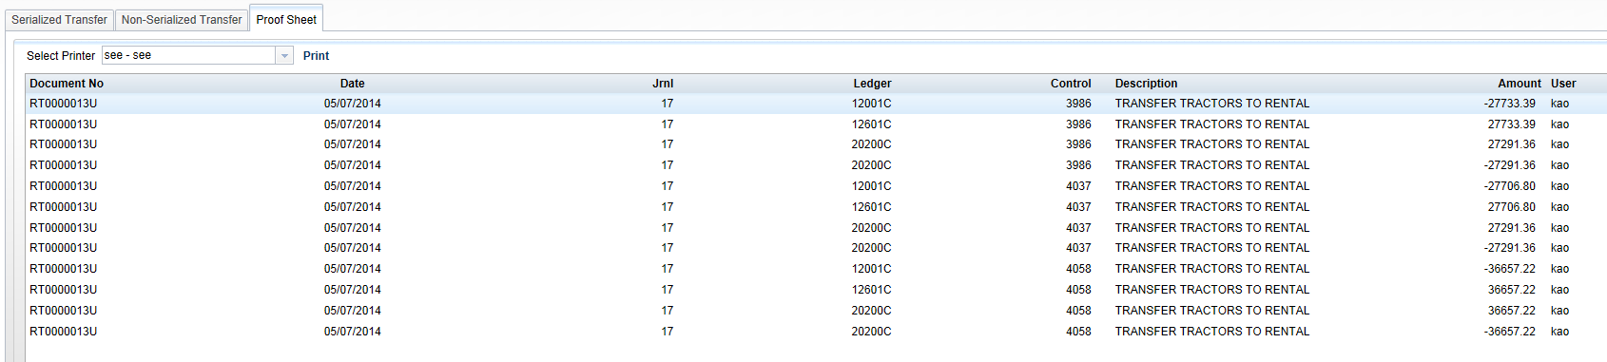
When posted, the Journal entry may look something like this:
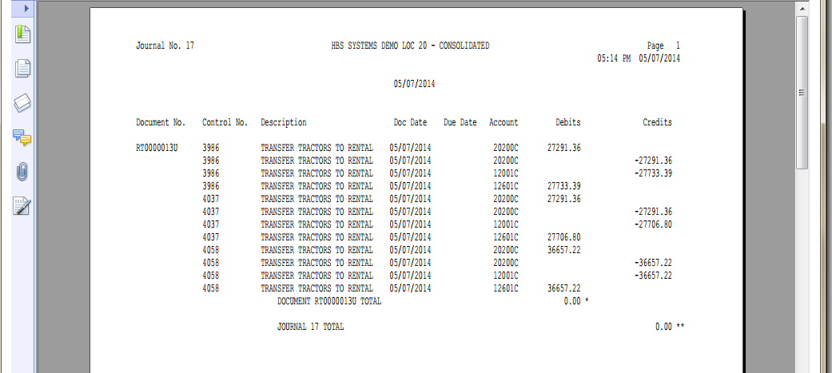
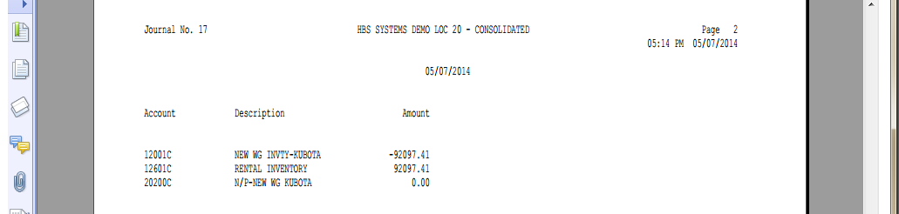

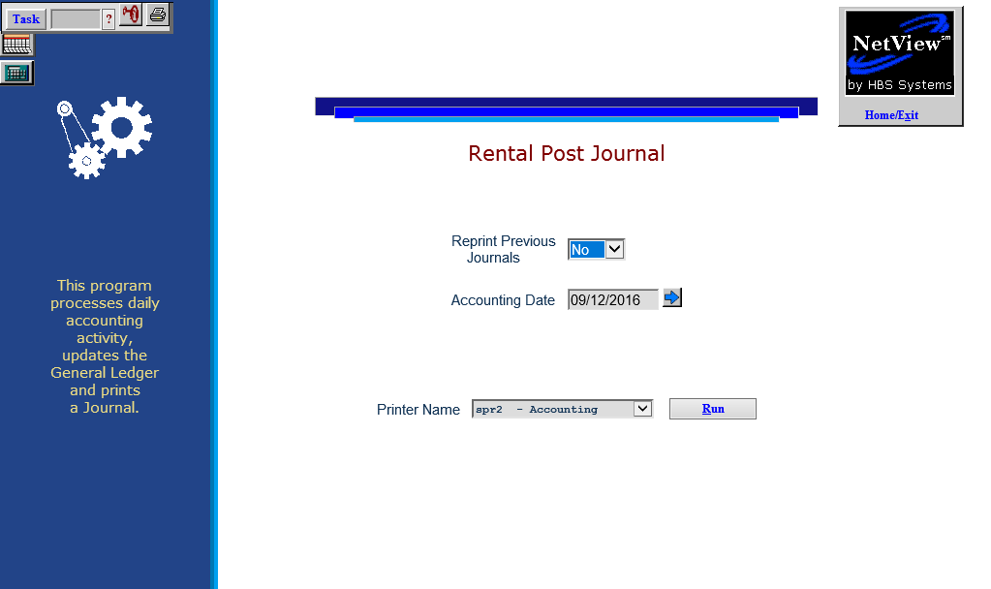
Rental Post Journal (RPJ) posts unit transfer transactions in Rental to the system. You should run the Journal after you make a transfer. To open this function, select the following from the menu:
Rental / Rental Post Transfer Journals
Or type RPJ in the Shortcuts Bar

Field Definitions
Reprint Previous Journals
Select Yes from the drop-down menu to reprint previous Journals. Select No to post the current Journal.
Accounting Date
Enter the accounting date or use the arrow to select it from a calendar. The current date fills as default.
Printer Name
Choose the printer to receive the Journals. Use the see or PDF printers to preview the document.
Click Run to post the Journal.
Sample Journal
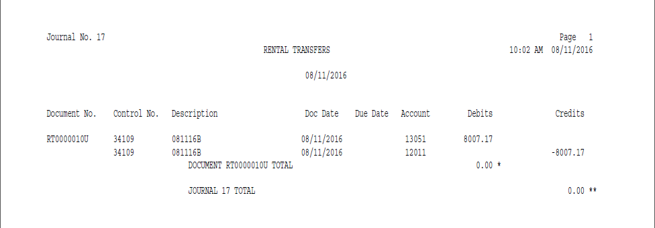

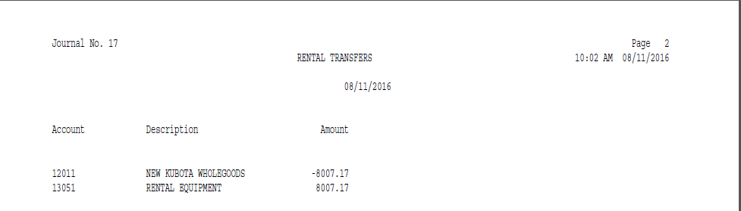

Rental Appendix: Recurring Billing Setup Guide (RRB)

For Full Month Rate Billing Only (Pre-bill):

Do not bill partial month rates in Rental Recurring Billing (RRB).
Number of days in the month is not important.
Customer is billed for future usage to the end of a billing period.

Set the rate for Monthly to “Calendar Month” in Rental Class Maintenance (RCM) for the class.
The max hours of the rate is normally set to 28 days. This can be optionally adjusted to 31 days (744 hours) to avoid potential partial month rate charges on final billing.
Set Rental Options and Defaults (ROD) options as follows:
- Pre-bill: ON
- Cycle: Day of Period
When running RRB, make sure the 28-day checkbox is unchecked. RRB can be run at the end of month, but running twice a month is recommended.

For 28-Day Billing (Pre-bill):

Do not bill partial month rates in RRB.
Customer is billed for future usage for 28 days.
13 billing cycles per year is desired.
Class rates should be “Hourly” (default) in RCM.
Set ROD options as follows:
- Pre-bill: ON
- Cycle: Calendar
When running RRB, make sure the 28-day checkbox is checked. RRB should be run at least weekly to catch changes in eligibility for billing.

For Usage Billing:

OPTION 1:

Customer is charged using all rates for time accumulated since last bill.
Class rates should be “Hourly” (default) in RCM.
Set ROD options as follows:
- Pre-bill: OFF
- Cycle: Calendar
When running RRB, make sure the 28-day checkbox is unchecked. RRB should be run daily to catch changes in eligibility for billing and to avoid potential partial month billing rates on invoices when possible.

OPTION 2:

Number of days in the month is not important.
Bill customer for accrued time of at least one billing period.
Set the rate for Monthly to “Calendar Month” in RCM for the class.
The max hours of the rate are normally set to 28 days. This can be optionally adjusted to 31 days (744 hours) to avoid potential partial month rate charges on final billing.
Set ROD options as follows:
- Pre-bill: OFF
- Cycle: Day of Period
When running RRB, make sure the 28-day checkbox is unchecked. RRB should be run daily to catch changes in eligibility for billing and to avoid potential partial month billing rates on invoices when possible.

Recurring Billing Option Definitions:

RCM “Monthly” Rate (504 – 744 Hours)

Hourly Straight hour eligibility based on min and max hours.
Calendar Month Ignores min and max hours. Uses calendar day from month to month as the eligibility criteria for the rate.

ROD/Contract Options

Use Recurring Billing Specifies that the recurring billing is active on this contract when running RRB.
Pre-Bill Bill for future usage for the specified period.

Billing Period Monthly=1 month
Quarterly=3 months
Semi-Annually=6 months
Annually=1 year

Billing Cycle

Calendar End of Month
Day of Period Uses day of contract start to determine when billing is to occur during the billing period.

